Part I

Earthquakes
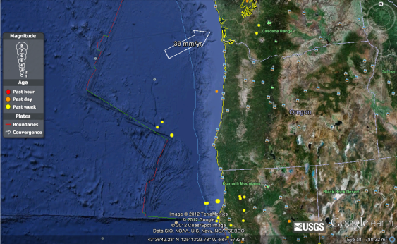

Magnitude: 5.9

Location: off the coast of Oregon

Date: Wednesday, April 11, 2012

Time: 22:41:47 UTC

Depth: 10.20km (6.34 mi)

Plate Boundary: Divergent

Why: This quake was caused by two diverging plates. When the two plates separate it allows the asthenosphere to come up and cause an earthquake.

Magnitude: 5.3

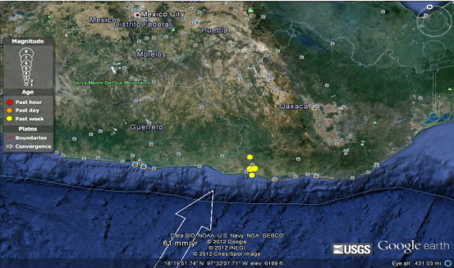
Location: Oaxaca, Mexico

Date: Friday, April 13, 2012

Time: 22:55:10 UTC

Depth: 14.30km (8.89mi)

Plate Boundary: continental-continental

Why: I believe that this earthquake was caused in this area of Mexico because of the two strong continental plates that push up against each other, thus making a plate on plate contact resulting in this type of earthquake.

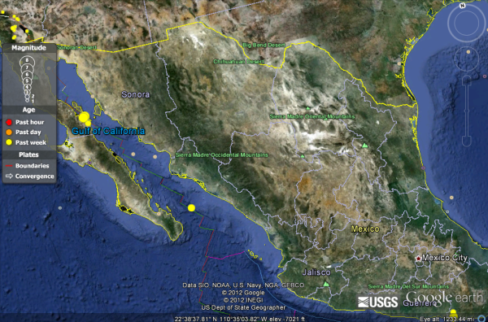
Magnitude: 5.0
Location: Gulf of California
Date: Monday, April 16, 2012
Time: 03:27:42 UTC
Depth: 10.30 km (6.40 mi)
Plate Boundary: Transform
Why: This quake was caused by two plates that once were aligned but now are sliding side by side in opposite was causing friction and producing an earthquake.

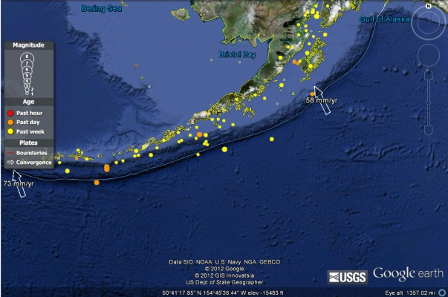
Magnitude: 4.5
Location: South of Alaska
Date: Monday, April 16, 2012
Time: 05:23:33 UTC
Depth: 10.10 km (6.28 mi)
Plate Boundary: Oceanic-Continental
Why: This quake was caused by two plates that once were aligned but now are sliding side by side in opposite was causing friction and producing an earthquake.

Magnitude: 6.2
Location: Drake Passage
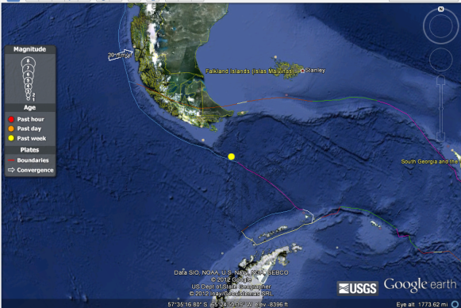
Date: Saturday, April 14, 2012
Time: 10:56:18 UTC
Depth: 9.90 km (6.15 mi)
Plate Boundary: Oceanic- Oceanic
Why: This oceanic to oceanic plate boundary quake was caused from buildup of tension on the ocean from right in the middle of these two plates. Once enough pressure built and was released, this caused the earth to quake.

Part II
Volcanos
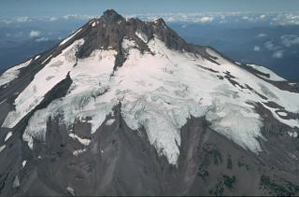

Name: Mt. Jefferson
Location: Oregon (USA)
Type of Volcano: Cinder Cone
Plate Boundary: convergent

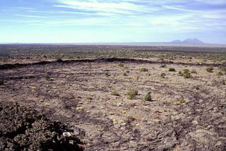

Name: Hell’s Half Acre
Location: Idaho (USA)
Type of Volcano: Shield Volcano
Plate Boundary: convergent

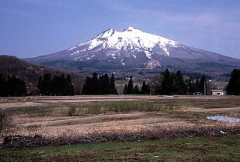
Name: Iwaki
Location: Honshu (Japan)
Type of Volcano: Composite
Plate Boundary: Oceanic-Continental

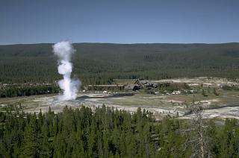
Name: Yellowstone
Location: Wyoming (USA)
Type of Volcano: Caldera
Plate Boundary: divergent

Part III
Reflection
It’s incredible how much I have learned about earth since beginning this class. We have been able to look at all different types of natural disasters. I have always thought that natural disasters are each a separate entity and do their own thing. I couldn’t have been more wrong. Looking at the earth with more of a scientific view I now see that hurricanes don’t happen without precipitation and volcanos don’t happen without fault lines and plate tectonics. It has really opened my eyes to see these great plates and how much damage they can do. And this doesn’t only include earthquakes, volcanoes are just as interesting.
I have learned a lot through taking this course. After taking science all thru high school I thought I had most of it figured out. However, I was shocked on how little I knew, especially when it came to earthquakes and volcanos. One of the biggest things I learned in relation to these two was how many of them lie on certain fault lines. It was interesting to see how they lined up and down the west coast of North America and around the Pacific Ocean. I never knew that these two great forces of nature could have such a deadly one-two punch when it came to destruction. Thru plates moving in the ground we get earthquakes but did you know from this seismic event we also get volcanos? I didn’t, but now I do.
This class has really shifted my views of natural disasters. I learned that no one is really safe from natural disasters, no matter where you live. I look at Utah and these great big mountains and I think well, at least I’m safe from tornadoes. Although, after this class, I might not see tornadoes but I do see giant fault lines running through the valley that one day could cause a giant earthquake. Through this course, I have seen and developed a greater respect for this earth and the power that lies within it. No matter where you live, what you do, or what you do to prepare for these forces, our earth will always have more control than us.

